- Create New Notice
Notice created will be shown in the main screen of the scheduler.
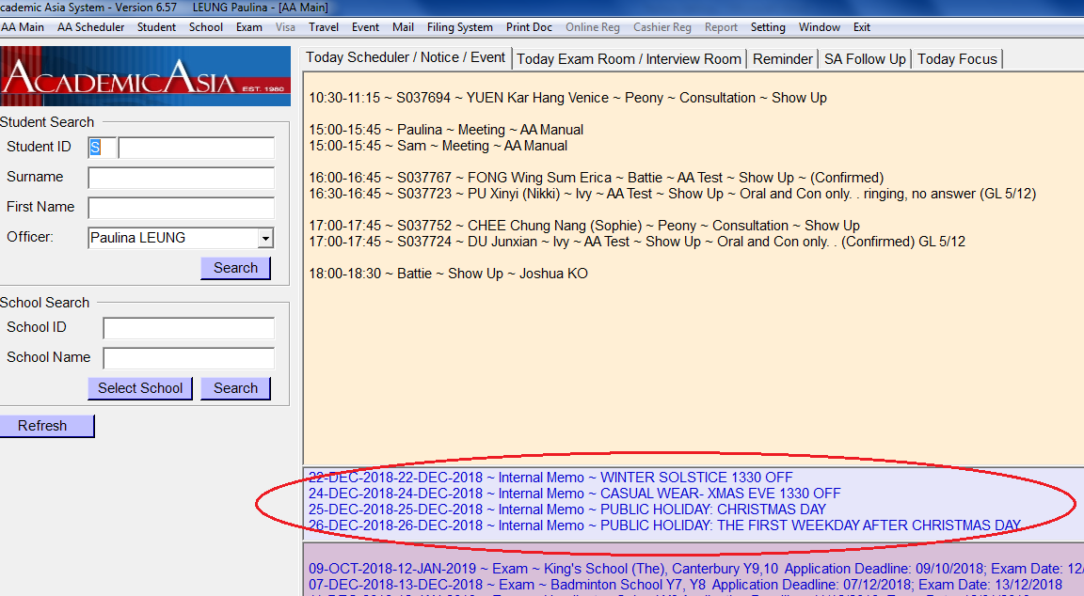

- Select Setting from the top menu bar, then choose Notice
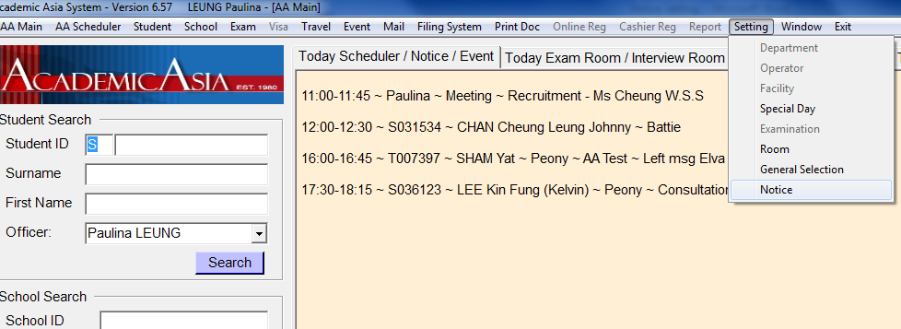

- After opening the Notice page, click the New button at the bottom to create a new notice
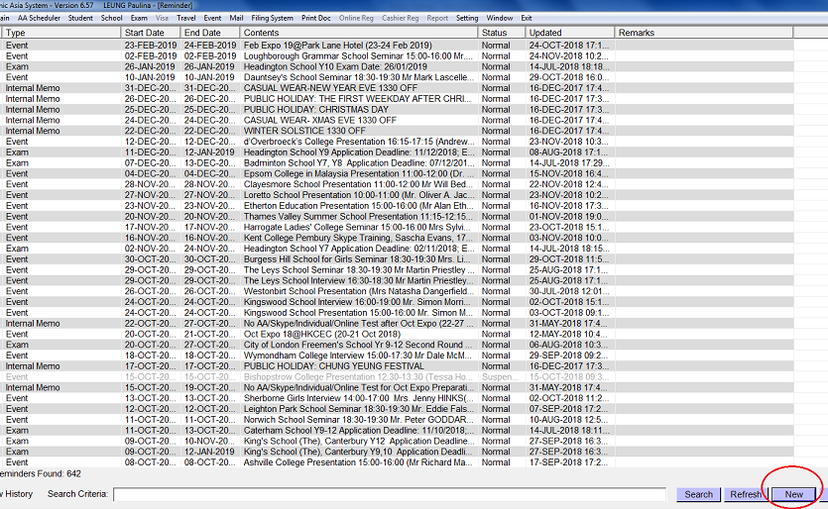

- Select the type of Notice from the field “Type”:
Internal Memo / Event / Exam / Others
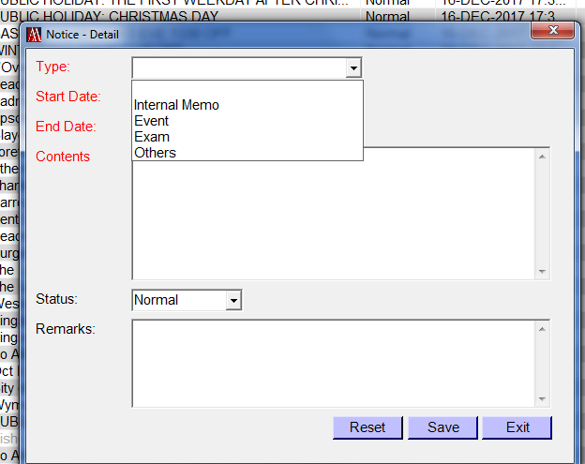

- Enter the start and end date, as well as the content of the event. 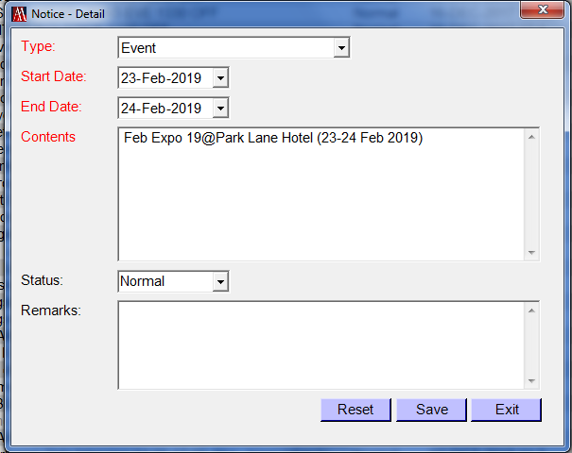
Type of Notice | Description | Example
Event | Expo - The content should include event name, venue and date | Feb Expo 19@Park Lane Hotel (23-24 Feb 2019)
 | Seminar/Presentation/Interview – The content should include event name, time and name of speakers (with title), and venue. | Clayesmore School Presentation 11:00-12:00 Mr Will Bedford (Head of External Relations)@Shakespeare
Internal Memo | - State the type of holiday/closing time, if office will be closed early  - State the period involved if the message covers a period of time | -CASUAL WEAR-NEW YEAR EVE 1330 OFF  -No AA/Skype/Individual/Online Test after Oct Expo (22-27 Oct)
Exam | State the school name, year group, application deadline, and exam date | King's School (The), Canterbury Y9,10 Application Deadline: 09/10/2018; Exam Date: 12/01/2019
Others | State event

- Press the save button at the bottom once all information has been entered.

- Click the Refresh button at the bottom to check if the newly created entry has been shown in the screen.
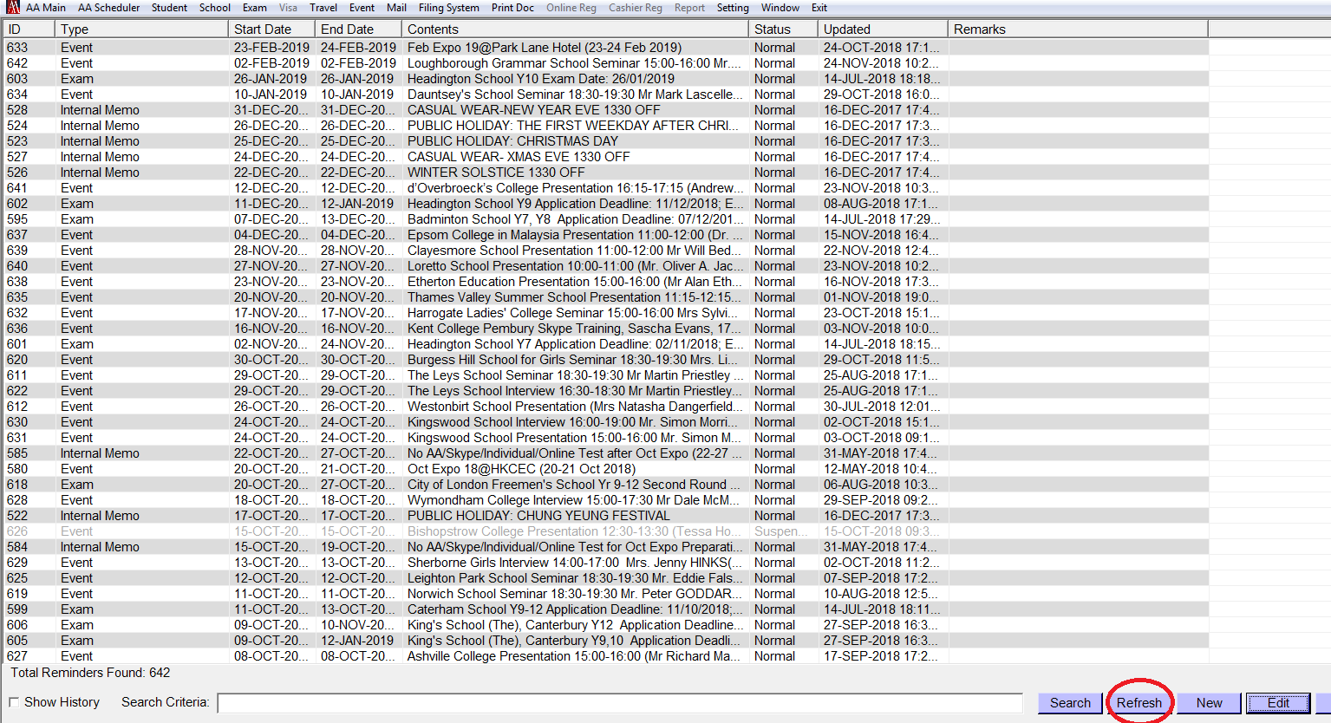

- To leave the setting screen, click Exit at the bottom
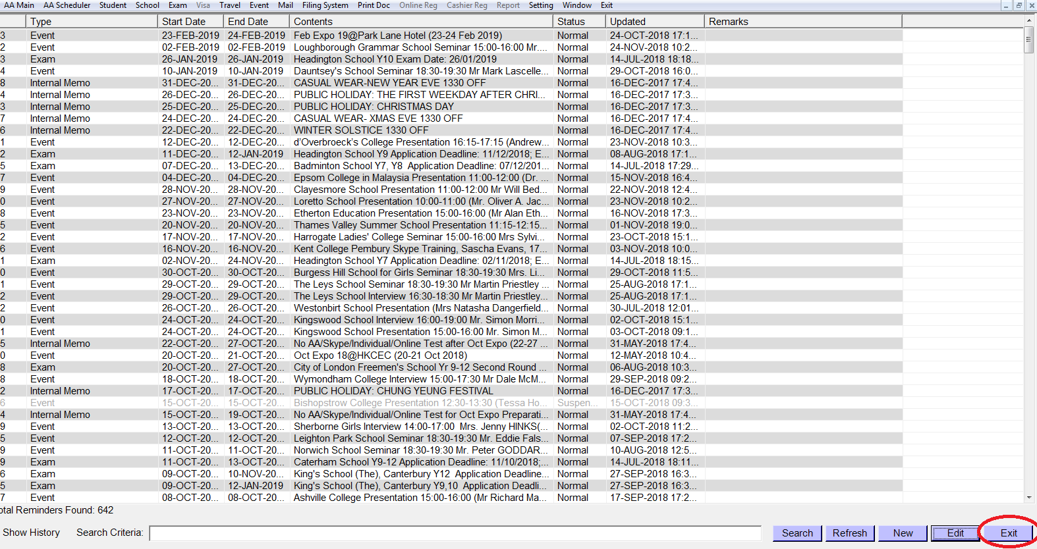

- Edit Notice
  - To edit an existing notice, select the notice entry that you wish to amend and click the Edit button at the bottom of the screen.
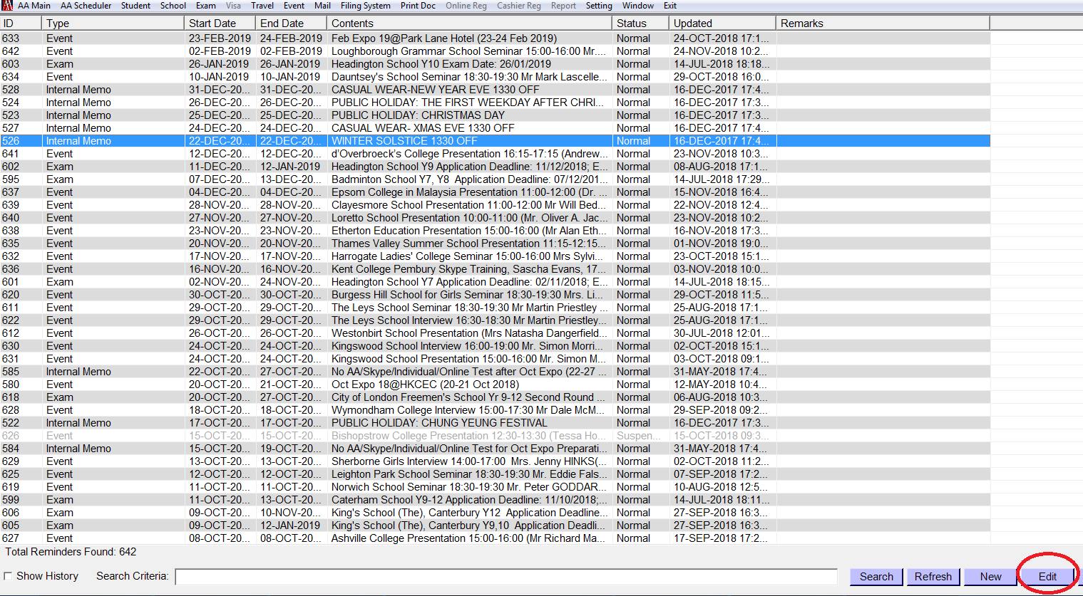

  - Amend the information in the notice, then press the Save button.
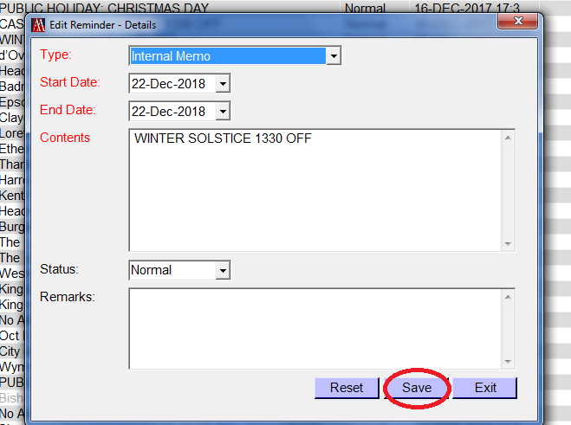

  - Click the Refresh button at the bottom to check if the newly created entry has been shown in the screen.


  - To leave the setting screen, click Exit at the bottom


